Hybrid Underwater Communications using sonar and Li-Fi Communications
Abstract:
Our proposed system aims to enhance the efficiency of underwater communication by solving the issues such as excessive energy use, limited bandwidth, delay in information and cost. This study introduces a hybrid communication framework combining acoustic and optical methods for Internet of Underwater Things (IoUT)applications. A memory efficient TinyML model be implemented at the underwater sink, processes sensor data to identify abnormal values and conditions like earthquakes, disasters, or severe water pollution. In emergency situations, the alert signals are sent to the substation through long range acoustic communication has it helps to alert fastly due to its long range communication. But for normal monitoring data, the data is conveyed through high-speed optical Li-Fi links to AUVs which then travels to substation and transfer the collected data. The AUVs has inbuilt solar panel on the top surface which will helps to get recharge when the battery is low through sunlight and also acts as the Li-Fi receiver so it reduces the energy consumption. In tough situations it is modelled to use both way communication and if cost permits we can also use Magnetic Induction(MI) communication which will be very useful if the water gets more turbidity in that case this way of communication is more efficient. This hybrid system uses only lower energy usage, extend the networks lifetime and ensure operations going to uninterruptedly.
Methodology:
This hybrid system communication is designed for Inter of Underwater Things(IoUT) applications. Intially, many underwater sensor nodes are placed in the deeper oceans to monitor continuously and also measure values like temperature, pressure, salinity etc. These nodes are connected to the uw-sink to locally process the sensor data from the nodes. The TinyML model in sink will analyze the datas and if it senses any abnormal conditions or values it will sends emergency alert data to the surface station directly through acoustic communication as it was effective for long-range underwater communication.
For normal monitoring data that doesn’t need to be sent immediately , so the system uses optical Li-Fi communication using AUVs which has solar panel implanted on the top of the AUVs which acts as the receiver and also if the battery is low the algorithm in the AUVs senses that then the AUVs go to the surface of ocean so that it will get recharged through sunlight. When sink gets all the values it uses the laser beam which LI-Fi Transmitter and it falls on the solar panel of AUVs to receive the data. In Tough situations when only one the underwater communication is unreliable, in that situations it is programmed to activate both communications which will efficient and transfer with minimal error rates either way of communication.
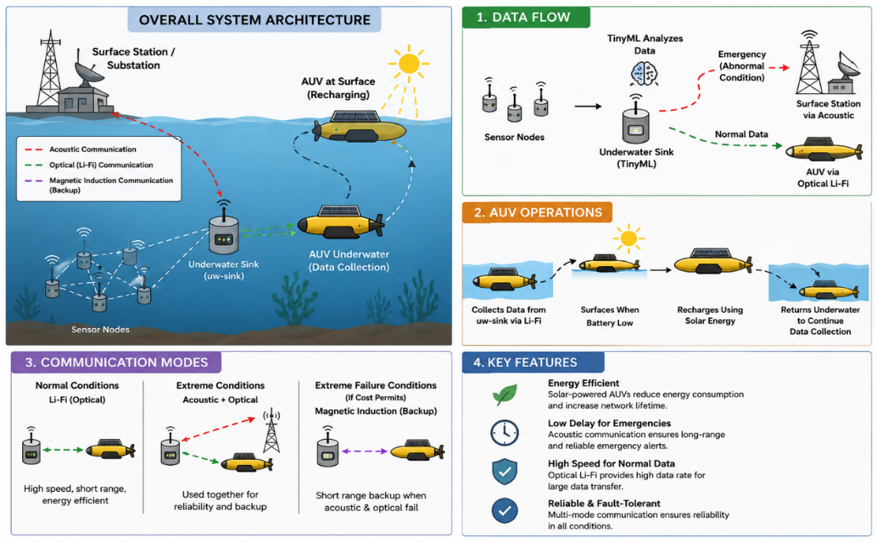
Figure 1: Visualizing the hybrid communication architecture as 1. Data flow, 2. AUV Operations, 3. Communication modes, 4. Key Features.
Discussion:
The proposed hybrid underwater communication system improves the reliability of efficiency of communication in underwater by means of combining the two different ways of communication i.e., acoustic and Li-Fi with TinyML intelligence in sink which boosts the connectivity and also reduces the process of analyzing after the data comes to the surface station before that this analyzes and gives the analyzed clean data. The use of solar powered AUVs which reduces cost and also increases the lifetime due to self-charging capacity also using solar panel to receive the data through Li-Fi. During extreme conditions both acoustic and Li-Fi communication are used together to improve reliability and backup support. In addition, in extreme conditions the third way of communication i.e., the magnetic Induction communication can be used if the budget of mission permits. Compared to traditional acoustic only system this hybrid system consumes lower power consumption and reduces the delay in information also better fault tolerance for underwater communications.
References:
- Saleha Al-Zhrani, Nada M. Bedaiwi, Intesar F. El-Ramley, Abeer Z. Barasheed, Ali Abduldaiem, Yas Al-Hadeethi, and Ahmad Umar, “Underwater Optical Communications: A Brief Overview and Recent Developments,” Engineered Science, vol. 16, pp. 146–186, 2021. DOI: 10.30919/es8d574.
- Kazi Yasin Islam, Iftekhar Ahmad, Daryoush Habibi, M. Ishtiaque A. Zahed, and Joarder Kamruzzaman, “Green Underwater Wireless Communications Using Hybrid Optical-Acoustic Technologies,” IEEE Access, vol. 9, pp. 85109–85124, 2021. DOI: 10.1109/ACCESS.2021.3088467.

